

Codution,

Uttam Nagar Sailai,

Firozabad, 283203 ( U.P), India

{{today_date}}

Dear {{name}},

We are excited to offer you an internship position with **CODUTION** for a period of **3 months**, starting on **09/02/2023**. During this time, you will have the opportunity to work closely with our team and gain valuable experience in {{job_title}}.

As an intern, you will be responsible for responsibilities and tasks. You will also have the opportunity to attend meetings and events, and to participate in any training or development opportunities that are offered.

We are looking forward to having you on board and to the valuable contributions we know you will make.

Please let us know if you have any questions or concerns. If you accept this offer, then reply with yes in 3 days of getting this offer letter after that it will expire .

Sincerely,

Divyanshi Gupta **Signature** 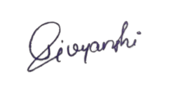

Head of HR Department Codution